Exp :- Design automatic led Diwali lights (consisting of 6 led’s) such that it only works during night and can generate two patterns which can be toggled with switch. a. Pattern 1 – led blinks with a freq. of 500 msec. b. Pattern 2 – led blinks with a freq. of 1 sec.

CIRCUIT DIAGRAM:-

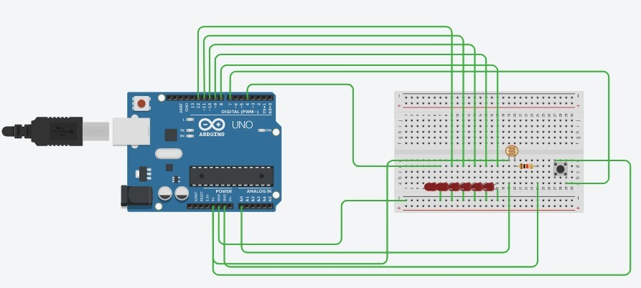

REQUIREMENTS:-

1. Breadboard
2. Arduino
3. 6 led
4. A switch
5. Light Dependent Resistor
6. Connecting wires
7. Resistor

THEORY:-

Take an led and determine its positive and negative ends.

Take a breadboard and determine the flow of current in breadboard

Make the circuit as shown in the diagram

Connect the ldr and switch in the breadboard .

Write a code and upload it on Arduino .

CODE:-

void setup() // run once, when the sketch starts

{

pinMode(LDR, INPUT);

pinMode(1, OUTPUT);

pinMode(2, OUTPUT);

pinMode(3, OUTPUT);

pinMode(4, OUTPUT);

pinMode(5, OUTPUT);

pinMode(6, OUTPUT);

// sets the digital pin as output

}

void loop() // run over and over again

{

val = digitalRead(LDR);

If(button state == high);

{

digitalWrite(4, HIGH);

digitalWrite(12, HIGH);

digitalWrite(-11, HIGH);

digitalWrite(-10, HIGH);

digitalWrite(-9, HIGH);

digitalWrite(8, HIGH);

// sets the LED on

delay(500);

// waits for a second

digitalWrite(4, LOW);

digitalWrite(12,LOW);

digitalWrite(-11, LOW);

digitalWrite(-10, LOW);

digitalWrite(-9, LOW);

digitalWrite(8, LOW); // sets the LED off

delay(val); // waits for a second

}

{if(button state==low);

digitalWrite(4, HIGH);

digitalWrite(12, HIGH);

digitalWrite(-11, HIGH);

digitalWrite(-10, HIGH);

digitalWrite(-9, HIGH);

digitalWrite(8, HIGH);

delay(1000);

// waits for a second

digitalWrite(4, LOW);

digitalWrite(12,LOW);

digitalWrite(-11, LOW);

digitalWrite(-10, LOW);

digitalWrite(-9, LOW);

digitalWrite(8, LOW); // sets the LED off

void loop() {

int ldrStatus = analogRead(ldrPin);

if (ldrStatus <=500)

digitalWrite(4, HIGH);

digitalWrite(12, HIGH);

digitalWrite(-11, HIGH);

digitalWrite(-10, HIGH);

digitalWrite(-9, HIGH);

digitalWrite(8, HIGH);

Serial.println("LDR is DARK, LED is ON");

}

else {

digitalWrite(4, LOW);

digitalWrite(12,LOW);

digitalWrite(-11, LOW);

digitalWrite(-10, LOW);

digitalWrite(-9, LOW);

digitalWrite(8, LOW);

Serial.println("LED IS NOTN DARK,LED IS OFF");

}

LEARNING OUTCOMES:-

ARDUINO UNO is an ATMEGA controller based board designed for electronic engineers . Arduino based program development environment is an easy way to write the program when compared to other environment development programs.

LDR is a light sensitive resistor which changes its value when light falls on them.

Precautions:-

1. Connections should be tight,there should not be any breakage.

2. LED should not be fuse.

3. Coding should be done properly